
Symbiosis Institute of Technology, Pune
Faculty of Engineering
CSE- Academic Year 2026-27
Java Programming – Lab Batch 2024-28
Lab Assignment No:- 16
Name of Student | Aarushi Raizada
PRN No. | 25070122002
Batch | 2025-29
Class | A1
Academic Year & Semester | 2026 Sem III
Date of Submission | 20th August’26
Title of Assignment: | Write a Java program to create and handle a user-defined exception.
Theory  Practice questions | User-defined exceptions are created by extending the Exception class. They allow developers to define  meaningful exceptions for specific business logic. Custom exceptions improve program readability and  simplify debugging by providing descriptive error messages. They are widely used in enterprise software and  validation systems.  1. Create a Voting System that throws a custom exception if age is below 18  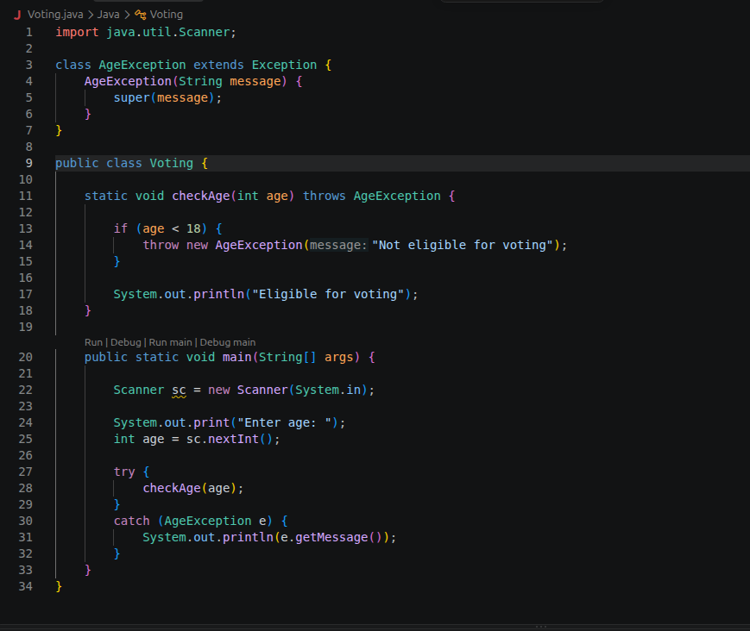  2. Create a Driving License System that throws a custom exception if the user’s age is below  18. If the age is valid, display that the user is eligible for a driving license  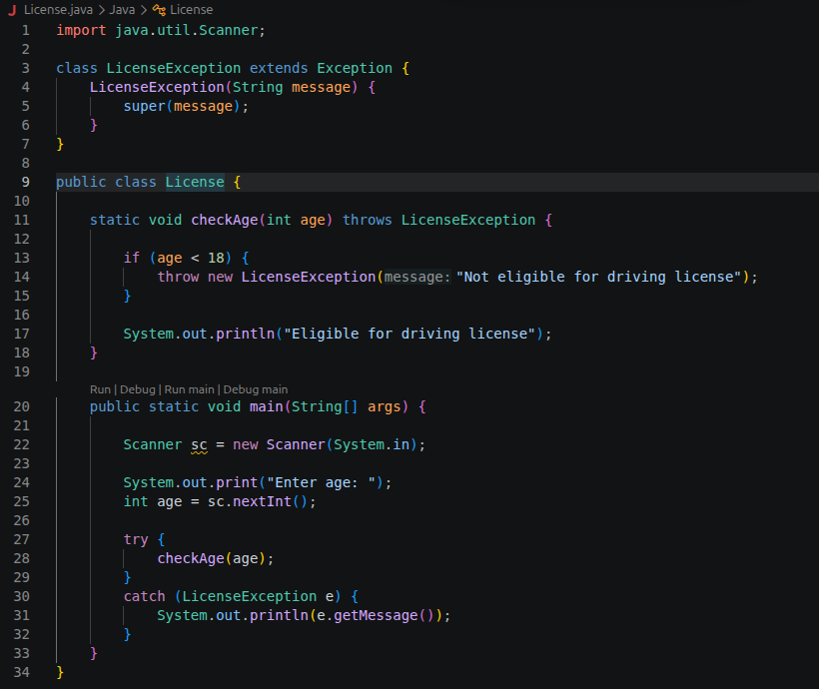
Output Screenshots (if applicable) | Ans 1  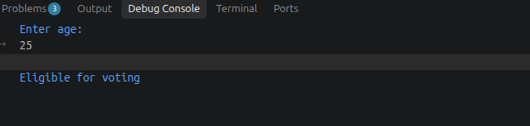  Ans 2
Conclusion | Thus, the Java programs for the Voting System and Driving License System were successfully implemented using user-defined exceptions. The custom exceptions correctly handle invalid age conditions and display meaningful error messages.

